# **Big Mountain Resort: Guided Capstone**

# Project Findings

## **Problem Identification Overview**

## **What strategies Big Mountain Resort’s Management team needs to resort to, in order to increase this year’s annual revenue and keep it at desired level expected by the Investors, while offsetting against increasing operating costs to maintain profit margin for the business at ~9.2%?**

Big Mountain Resort, who has recently installed an additional chair lift to increase distribution of visitors across the mountain has resulted in the operating costs increasing by $1,540,000 this season. The resort investors are looking for a solution to increase this year’s annual revenue in the form of more footfalls to offset the increasing operating costs keeping in mind that it faces tough competition from nearly 330 resorts in the US.

## **Data**

Data cleansing was performed primarily focusing on the following

* Handling the missing and NA values
  + Which were handled mostly using mean, ffill and fillna methods
* Removing duplicate rows
  + However, no duplicate rows were identified

## **Model Description and Performance**

### **Models applied**

### *Linear Regression*

Linear Regression was applied since there was a strong co-relation observed based on heat map created for the dataframe. The objective was pretty clear that there was a need to determine which variable had highest impact on the price of Weekend ticket price in order to achieve the objective of increased revenues

### *K-means Clustering*

K-means Clustering was further applied to put the cleaned dataframe into groups (or 'clusters') for conveying findings in a clean graphical format. Number of clusters was set to 3 as determined by Elbow method

### **Modeling performance**

|  |  |  |  |
| --- | --- | --- | --- |
| **Model** | **Explained Variance** | **Mean Absolute Error** | **Features Dropped** |
| Model 1. | 0.92 | 5.46 | - |
| Model 2. | 0.91 | 5.77 | 'state' |
| Model 3. | 0.92 | 5.70 | 'state','summit_elev','base_elev |

### **Coefficients of co-relation**

With chosen Model 2, since ‘states’ were necessary to be removed from the cleaned dataframe in order to predict the average weekend price of ‘Big Mountain Resort’, following are the coefficients of co-relations between all independent variables and Average Weekend Ticket price (Dependent variable)

|  |  |
| --- | --- |
| **Variables** | **Coefficients** |
| **AdultWeekday** | 20.290758 |
| **base_elev** | 5.069323 |
| **summit_elev** | 4.405048 |
| **averageSnowfall** | 1.471846 |
| **quad** | 1.255350 |
| **surface** | 1.000788 |
| **fastQuads** | 0.963656 |
| **triple** | 0.904347 |
| **NightSkiing_ac** | 0.696030 |
| **total_chairs** | 0.609234 |
| **Runs** | 0.567704 |
| **daysOpenLastYear** | 0.555854 |
| **projectedDaysOpen** | 0.477440 |
| **LongestRun_mi** | 0.468372 |
| **vertical_drop** | 0.380968 |
| **SkiableTerrain_ac** | 0.343201 |
| **fastSixes** | 0.325714 |
| **yearsOpen** | 0.240124 |
| **trams** | 0.234007 |
| **Snow Making_ac** | 0.233699 |
| **double** | 0.156957 |
| **TerrainParks** | 0.112444 |
| **fastEight** | 0.037744 |

## **Model Findings**

### **Co-relations**

The most highly co-related variables to **AdultWeekend** (Weekend ticket price $) are

* Adult Weekday ticket price
* Base elevation
* Summit elevation

### *Relationship between Summit elevation and Vertical drop (terrain height and depth features)*

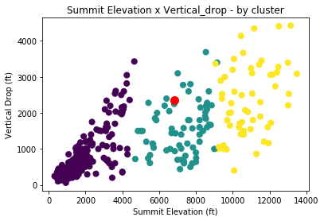

### *Relationship between Summit elevation and Adult weekend ticket price (Highest co-related variable after Weekly Ticket price)*

## 

### *Relationship between Base elevation and Adult weekend ticket price (Highest co-related variable after Weekly Ticket price and Summit elevation)*

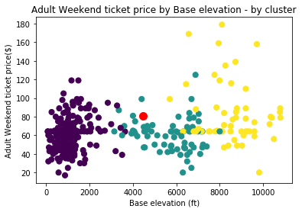

### **Model Predictions**

The actual Weekend ticket price for ‘The Big Mountain Resort’ is $81, however, going by the predictions using the modeling, the expected ticket price should be targeted at $91.14 to stay in-line with the other resorts depending on varied features Big Mountain offers vs. them. These increased ticket prices should help the Management achieve their goal of 9.2% of profit margin despite increased CAPEX

## **Next Steps**

Similar prediction and model findings can be done for the following response variables; but is not part of the scope of this project

* Average Weekday Ticket price
* Projected Days to be opened